Kinematics is a subfield of physics concerned with the motion of points, bodies (objects), and systems of bodies (groups of objects) without considering the forces that cause them to move
Position ,x
Velocity,v
Acceleration,a
Time,t

Object dropping/moving doesn’t depend on mass of object.
(Vector – magnitude and direction)
Vectors - angles, using position vector : update pos vec every frame using above formula with the necessary input.
Mass- amount of matter in object,unit- kg
Mass constant , weight depend on force acting(like gravity).
Newton laws - 2nd Law = F=m*a
unit = kg m / s² or N (Newton)

On 1kg force acting using gravity ,F=9.8N
on 100kg force acting using gravity , F=980N
In slope force acting=
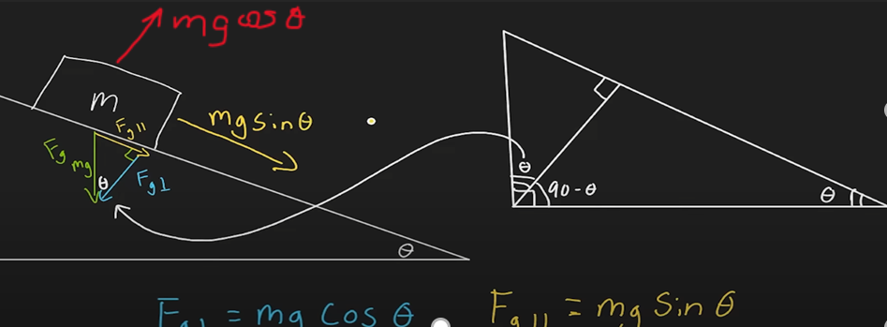
Friction:
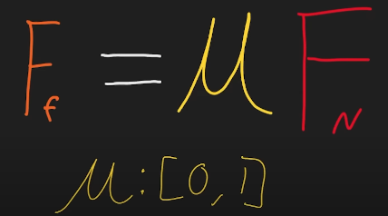
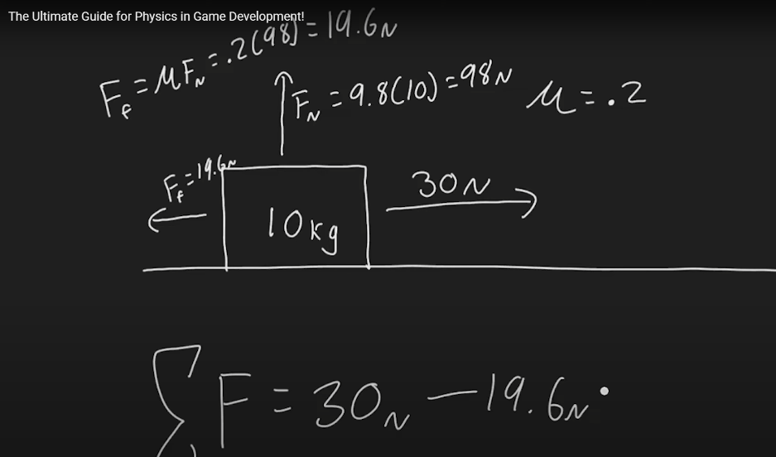
Static friction is frictional force which acts between the two surfaces when they are in the rest position with respect to each other.
Dynamic friction is frictional force which is created between any two surfaces when they are in a moving position. It is also called Kinetic Friction.
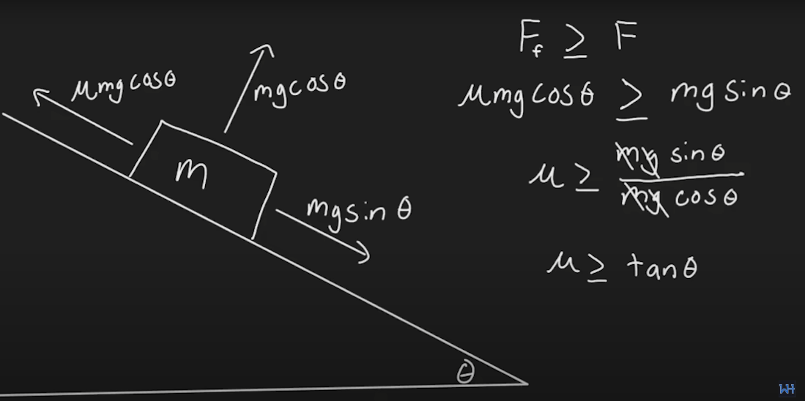
Drag- Air resistance
Resistance/opp. force acting on a free falling object in a medium.
After a while the opp. force (drag) gets equal to acceleration due to gravity(Fg)
making object reach a constant velocity(Terminal velocity)
Momentum:
the quantity of motion of a moving body, measured as a product of its mass and velocity.
p=m*v
Momentum is always conserved
Law of conservation of momentum is:
Momentum before and after collision is same
Elasticity-
Elastic collision - no energy(kinetic) is lost when collision of bodies
Inelastic collision- Some energy lost
Perfect Inelastic- all energy is lost
Kinetic energy(1/2 m*v²)
Impulsive Force/Impulse-
Force acting at an instance.
Impulse=F* dt
or change in momentum=dP
Rotational Motion:
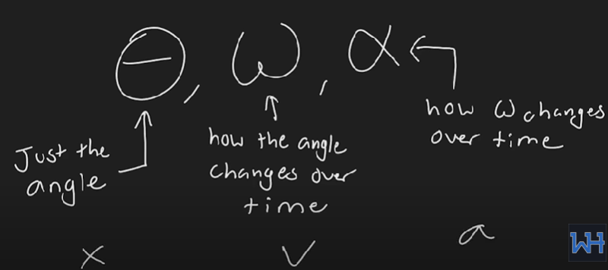
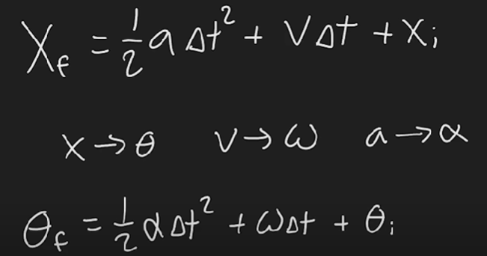
Torque-
Force required for rotation about obj axis.
Torque= F*r*sin theta
theta is angle between force and axis of r.
Torque = I * alpha
(I =inertia,alpha =angular acc.)

